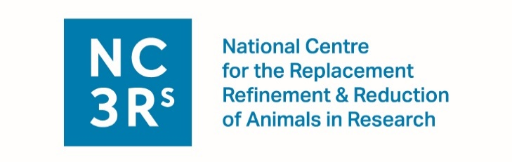
GW4 3Rs Symposium 2018
6 December 2018, Hadyn Ellis Building, Cardiff University, CF24 4HQ
ATTENDEE APPLICATION FORM
(to submit a poster abstract please also complete the section below)
Please note that priority will be given to those who are presenting posters. Deadline for registration is Friday 16 November.
Title
First name
Surname
Job title/role
Organisation
Work address
Postcode
Email address
(This must be your work email address)

Dietary requirements (i.e. vegetarian, allergies, etc.):
Please indicate whether your name and affiliation can be included
in a list of attendees in our delegate packs Yes/No
Please indicate if you would like to be kept informed of future NC3Rs events Yes/No
POSTER ABSTRACT SUBMISSION
PLEASE NOTE: your poster must highlight how you are applying the 3Rs to your work otherwise we regretfully cannot accept it for presentation.
This form must be emailed to regionalevents@nc3rs.org.uk by Friday 2 November.
Title of poster
Abstract (250 words)
3 keywords

