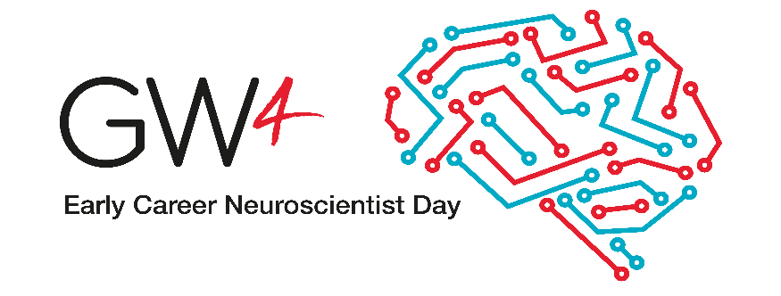

Early Career Neuroscientist Day 2019

09.30-10.00 Bristol and Exeter registration and poster set up with Tea/Coffee/Biscuits
10.00-10.30 Bath and Cardiff registration and poster set up with Tea/Coffee/Biscuits

Chair – Soraya Meftah
10.30 – 11:30 Opening Address by Dr Sarah Perkins, Director of GW4

Plenary - Professor Emma Robinson, Professor of Psychopharmacology, University of Bristol
Investigating neuropsychological mechanisms of antidepressant drug action using a novel rodent model

Lecture Theatre, RILD Building

11.30 – 12.15 Poster Session A with Tea/Coffee – RILD Building Atrium
Chair – Dr Isabel Castanho
12.15 – 13:00 Plenary – Professor Anthony Isles, Professor of Neurogenetics, Cardiff University
Genomic imprinting; an epigenetic rheostat mediating the effects of the in utero environment on brain and behaviour

13:00 – 14:00 Lunch break

14:00 – 15:00 1st Breakout sessions Chair – Gemma Shireby
Breakout 1 – Computational Neuroscience/Neuroscience Futures short talks – Seminar Room 8
14:00-14:20 Dr Georgina Hazell, British Neuroscience Association
A credible future for neuroscience

14:20-14:40 Professor Krasimira Tsaneva, University of Exeter
Computational modelling and analysis of altered intrinsic excitability of hippocampal pyramidal neurones in mouse models of pathologies associated with Alzheimer’s disease

14:40-15:00 Dr Diana Dima, Cardiff University
From features to faces: towards a computational account of visual perception

Breakout 2 – Alternative Careers short talks – Seminar Room 9 Chair – Szi Kay Leung
14:00-14:20 Dr Laura Palmer, University of Bristol
The South West Dementia Brain Bank: an invaluable research resource

14:20-14:40 Dr Emma Laing, Eli-Lilly
How does research in industry compare to academia?

14:40-15:00 Dr Vlad Anton, Charles River Associates
Launch Your Career in Life Sciences Consulting

15:00 – 15:45 Poster Session B with Tea/Coffee – RILD Building Atrium

15:45 – 16:45 2nd Breakout sessions
Breakout 1 – Scientific Techniques short talks – Seminar Room 8 Chair – Harry Farmer
15:45-16:05 Dr Aaron Jeffries, University of Exeter
Long read sequencing to define the brain transcriptome

16:05-16:25 Dr Michael Ambler, University of Bristol
Torpor TRAP: How to functionally identify circuits when you don’t know where to look

16:25-16:45 Dr Mouhamed Alsaqati, Cardiff University
The molecular mechanism underlying Ehmt1 regulation of REST in neurodevelopment via suppression of miRNAs-dependent REST

Breakout 2 – Dementia short talks – Seminar Room 9 Chair – Jenny Imm
15:45-16:05 Maria Garcia Garrido, University of Exeter
Impairments in neural correlates of contextual memory in a mouse model of amyloidopathy

16:05-16:25 Judith Piegsa, University of Exeter
Ca²⁺ Signalling In Human Brain Pericytes: Investigation of the Effects of Vasoactive Agents

16:25-16:45 Dr Isabel Castanho, University of Exeter
Mapping genomic consequences of Alzheimer’s disease pathology in amyloid and tau mouse models
Chair – Lauren Revie
Breakout 3 – Cognitive neuroscience short talks – Seminar Room 11

15:45-16:05 Axel Vitterso, University of Bath
Representations of the body and peripersonal space during tool-use in Complex Regional Pain Syndrome

16:05-16:25 Marlou Perquin, Cardiff University
MEG correlates of mind wandering and behavioural variability

16:25-16:45 Matthew Wilkinson, University of Bristol
Investigation of rapid and delayed-onset antidepressants in a translational reward learning task

Chair – Hellen Jing Yuan

16:45 – 17:30 Plenary – Professor Katie Lunnon, Associate Professor in Epigenetics, University of Exeter
Epigenetics of Alzheimer’s disease

Lecture Theatre, RILD Building

Chair – Prof Katie Lunnon
17:30 - 18:00 Close of meeting by Professor Clive Ballard, Pro-Vice Chancellor & Professor of Age-related Diseases, University of Exeter

Awards Announcement (short talks and posters)

Lecture Theatre, RILD Building

18.00 – 19.00 Drinks Reception with Food

RILD Building Atrium

