

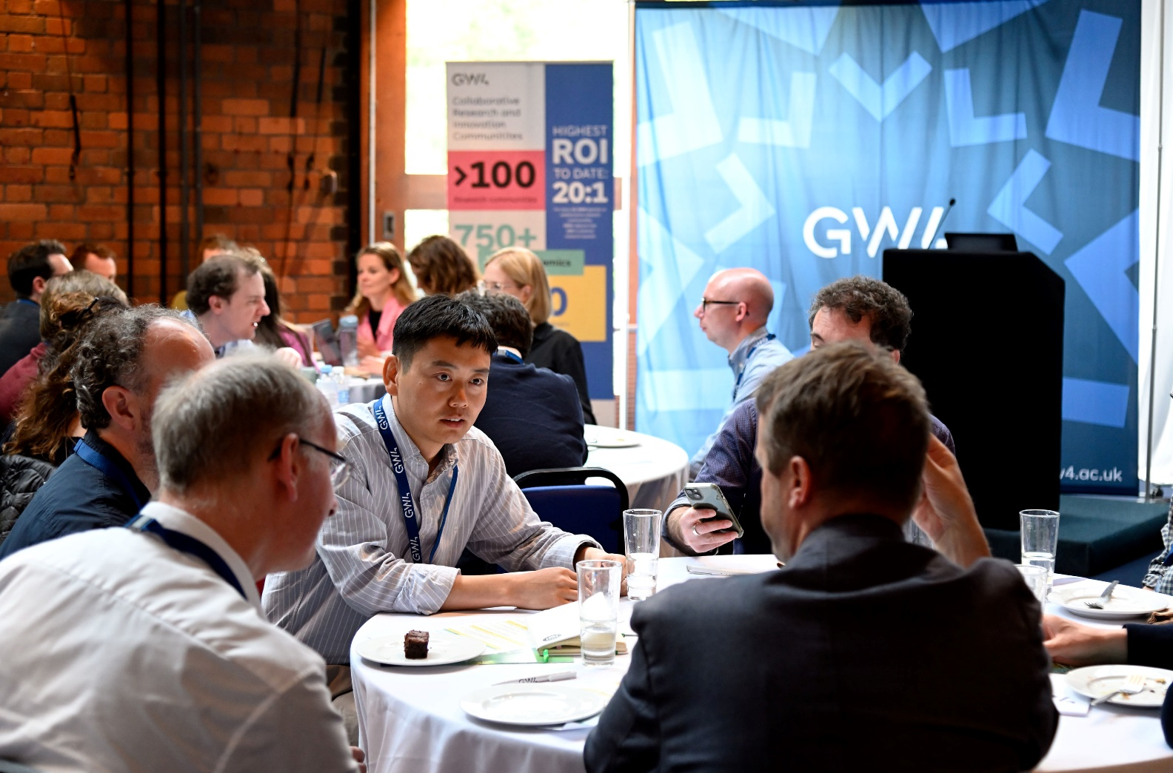


GW4 BUILDING COMMUNITIES
GENERATOR FUND GUIDANCE

BACKGROUND
The GW4 Alliance brings together four of the most research-intensive and innovative universities in the UK: Bath, Bristol, Cardiff and Exeter. Its vision is to develop pioneering, collaborative endeavours to drive innovation and economic growth across the Great West region.

The GW4 Building Communities Programme aims to build research communities of scale and capability that will deliver a step change in world-class research and innovation which could not be achieved by one of the institutions alone. GW4 seeks to work across all areas of academic activity, aiming to open up new opportunities for collaborative research and innovation; develop shared research infrastructure, equipment and other resources; identify and work with external partners; seek joint capital investment; set up postgraduate training partnerships; and support staff leadership and development initiatives.

The GW4 Building Communities Programme offers two funding streams; the Generator Fund, our annual funding scheme to which this guidance applies, and the Development Awards (our rolling funding scheme, more information on which can be found here). These funding streams support both new and existing GW4 research and innovation communities to collaborate and develop new lines of academic enquiry. The communities can be in any area of academic endeavour with the purpose of addressing a major research or societal challenge and should look to engage both academic and external partners. The Generator Fund supports more substantial projects with multiple activities. Development Awards are smaller and support GW4 collaborations by funding a single activity or resource.

The Generator Fund has a limited amount of resources and is highly competitive. Generator Fund awards will only be offered to outstanding projects that meet all the assessment criteria.

GENERATOR FUND OUTLINE:

- The Generator Fund aims to support both the creation of new GW4 communities and the development of the strongest ideas emerging from our existing communities.

- Applications up to a maximum of £20K are invited for activities over a 6-month period, starting June 1st 2026.

- The call is open to communities in any area of research or innovation. Interdisciplinary research is explicitly encouraged.

- Applications from Early Career Research (ECR) communities are particularly welcome.

- The application deadline for Generators Round 6 is Monday 2nd February 2026.

THE AIMS OF THE GW4 BUILDING COMMUNITIES PROGRAMME
  - To enable activities that bring together communities of academic staff with excellent and complementary expertise and capability.
  - To address research questions with potential for high impact that could not be carried out by any single institution.
  - To facilitate exploration of ground-breaking interdisciplinary research and innovation concepts to a point at which significant external funding can be sought.
  - To identify and engage external partners to provide step-change collaborations.
  - To clearly demonstrate the added value of the GW4 collaboration.

GUIDELINES

WHAT IS THE GENERATOR FUND FOR?
- This funding is for community building activities that enable:
- new, or previously informal, communities to come together to scope and refine research ideas and identify potential collaborators.
- existing GW4 communities to explore an identified opportunity that could be a new area of inquiry, and/or preparation for a specific funding stream.
- Generator funding is available for workshops, sandpits, writing retreats or other community building activities that enable communities to scope and refine research ideas and identify and engage potential collaborators and external partners.
- Generator funding is also available for pump priming activities with the potential for sustainable, step-change collaborations and research and innovation that engage both academic and external partners. The expectation is for communities to use the Generator Fund as a step towards applying for external funding.

ALL APPLICATIONS MUST:
- Involve at least three GW4 institutions, with communities involving all four partners preferred. Where fewer than four are involved this will need to be fully justified. Each GW4 institution has a GW4 Programme Manager who can help put you in touch with appropriate partners.
- Articulate and evidence the added value of working across GW4. This may be in terms of new interdisciplinary groupings, capacity and capability building, complementarity or synergy of expertise, academic endeavours and the ability to attract external funding.

BUDGET
- Applications up to a maximum £20k are invited.
- Eligible costs are travel and subsistence, consumables, meeting costs, research assistant support, external speakers or facilitators, equipment (small purchases only, justifiable in line with project deliverables), venue and catering costs, and administration support (only where fully justifiable within the context of the proposal). Note that internal research facilities costs, technician and support staff salaries are usually eligible, please email communities@gw4.ac.uk to discuss specific cases.
- Ineligible costs include academic salaries, studentship fees and other indirect costs.
- Costings should be drawn up and approved in line with local internal processes including finance compliance. Note that if budget is to be held at Bristol or Exeter, a Worktribe costing will need to be completed. Applications where costs are unclear will be returned for clarification.
- Generator funding can be used as a stand-alone award or in conjunction with other funding.
- We encourage budget to be entirely held at the Lead (PI’s) Institution. We will allow budget to be split across institutions if required, but budget allocated to CoI Institutions should only be for workshop expenses, staff salary expenditure etc – i.e. only things that cannot be claimed as an external expense. Budget for staff expenses (such as travel, accommodation, etc) should all be held at the Lead Institution and CoIs should claim as an external or the Lead Institution should book and pay for these.

TIMESCALE
- All Generator funded activities are expected to be completed in a six-month period, starting 1st June 2026.
- Applicants should ensure that activities are planned and scheduled so that in the event of an award, activities can be undertaken rapidly. Applicants will be informed of their outcome after Easter 2026, to allow for project preparation and for budgets and paperwork to be in place.
- Extended project timelines may be considered by the Building Communities Panel but only where they are fully justified and proportionate to the scope of the project.

PLEASE NOTE
- The Lead Applicant will be responsible for all arrangements for any events, activities and participation.
- Leads are welcome to contact their institutional GW4 Programme Manager to discuss potential applications and are encouraged to talk to the Building Communities Manager with specific queries communities@gw4.ac.uk.
- Prior to application, all applicants should discuss the impact of an award on their workload with their line manager.
- Awards count as internal funding for grant reporting purposes.
- Communities cannot hold overlapping Generator Funding and Development Awards.
- GW4 is committed to supporting Early Career Research (ECR) communities that are building capacity and capability for leadership. If any of your community are ECRs please indicate this, as directed, on the application form.
- GW4 is committed to supporting all research disciplines equally. To aid assessment, please ensure your application clearly justifies the scope of your proposed activities, outputs and outcomes within the context of your discipline norms.
- Previous successful applications may be obtained by contacting your GW4 Programme Manager.
- All funded applications will be promoted via the GW4 website and social media channels.
- Communities are expected to adhere to GW4 branding and communication guidelines.
- For information on previously funded GW4 communities please see our website here.

AWARD MANAGEMENT AND REPORTING
- Successful communities are expected to attend a Generator Showcase and Launch event on Thursday 21st May 2026, at Watershed Bristol to present their project, network with and learn from past and current communities and meet the GW4 Team.
- During the award the community is expected to meet with the Building Communities Manager for catch-up calls to track progress and identify issues or further support GW4 can offer.
- Following the end of an award, communities are expected to complete a Community Tracking Form and End of Award Report on the GW4 SharePoint and meet with the Building Communities Manager in a final award call.
- Communities are expected to participate in evaluations and updates, and promotional and communication events, as appropriate, during their funding and annually following the end of their award, including news stories and case studies.
- Communities are expected to send a representative to the Showcase and Launch event in May 2027 (after their project has ended) to showcase their project activities and share their experience with new communities.

APPLICATION PROCESS AND KEY CONTACTS
For further guidance on how to complete your application form, refer to the annexes and the recorded webinar available online.
Applicants are to complete the Generator Fund Application Form and email it to the Building Communities Manager by end of Monday 2nd February 2026 (communities@gw4.ac.uk).
All lead applicants are expected to follow the relevant internal processes and consult local guidance, particularly with reference to costings.
GW4 Programme Managers can also provide institutional guidance and signposting:
BATH | Kate Charles  kec34@bath.ac.uk
BRISTOL | Emma Barrow  emma.barrow@bristol.ac.uk
CARDIFF | Kate Patten  PattenK1@cardiff.ac.uk
EXETER | Helen Bell  H.E.Bell@exeter.ac.uk

MONITORING AND EVALUATION OF GW4 BUILDING COMMUNITIES PROCESSES

ASSESSMENT
Applications will be assessed and considered by the GW4 Building Communities Panel. Applicants will be notified of their outcome in April 2026.
The Building Communities Panel consists of academics selected equally from the four GW4 institutions, balanced across discipline area and career stage and supported by processes that ensure assessment is undertaken independently and objectively against fund criteria. The Panel is chaired by the GW4 Board Chair.

EQUALITY, DIVERSITY AND INCLUSION (EDI)
GW4 is committed to supporting a positive and inclusive culture and embedding best practice. The Building Communities Programme provides equality of opportunity and actively encourages applications from academics across all career stages (including ECR) and backgrounds. Our review processes are monitored to ensure fairness, and wherever possible, diversity. We collect and analyse our applications to monitor the balance between STEM and HASS discipline (data available on request) and EDI data will be collected (please note that providing this information is voluntary, see the Generator Application Form for further information).

INTEGRITY, ETHICS, OPEN RESEARCH
Any research undertaken with the support of Generator Funding must follow the appropriate GW4 institutional policies for research ethics and integrity.
As part of membership of the UK Reproducibility Network GW4 institutions each have local network leads. We would encourage applicants to discuss their plans with these colleagues to increase potential reproducibility of their research and reinforce excellence in their activities.

BUILDING COMMUNITIES PROCESSES
The Building Communities Programme processes are subjected to an ongoing programme of review and strengthening to ensure they remain robust and transparent.

FEEDBACK AND RESUBMISSIONS
Limited feedback on applications is given on request and resubmission is by invitation only.

KEY DATES – GW4 GENERATOR FUND
Call Opens | 19 November 2025
Call Closes | 2 February 2026
Review Panel | After 16 March 2026
Notification of Awards | Early April 2026
Showcase and Launch Event* | 21 May 2026
Project period | 1 June 2026 –  30 November 2026
*note that all members of successful communities are expected to attend the Showcase and Launch event which will be at Watershed, Bristol.

ANNEX ONE: Assessment Criteria for the Generator Fund
This table has been drawn up to assist applicants when completing their Generator application forms. The purpose is to explain the type of information and evidence required to satisfy the assessment criteria.

Assessment Criteria | Type of Evidence Required
- Strategic Fit | This component draws on the assessment and scores of the following three criteria. This determines the overall fit of the proposal to the aims of the Building Communities Programme.
1A. Step change | Clear statement about why potential outcomes and impact (e.g. interdisciplinary, capability and capacity, unique and distinct opportunity) from the proposed research is only possible, or significantly enhanced, as a result of it being undertaken by a GW4 community rather by an individual academic or institution.  Where appropriate, use baseline data to explain why your proposal represents a step-change in your research area.
1B. Outcomes: leveraging funding and publications | Anticipated or actual plans for how the community will leverage external funding as a direct result of this award. Where possible:  (1) provide specific information to evidence the estimated value of bids, how and when they will be written, to whom and when they might be submitted  (2) make specific reference to high quality publications, conference papers, policy documents/reports or other to be written as a direct result of the award; to whom they might be submitted and by when.
1C. Creating Impact | Communicates how it is anticipated this award will create impact to benefit each of the GW4 institutions as well as the wider society at a local, national, international level. Provides information about whether the community plans to engage with specific external partners to provide a step-change (if relevant).  What is this potential impact (academic and non-academic), when might it be felt and what plans are in place to help achieve this?
- Award Delivery | This component draws on the assessment and scores of the following three criteria.
2A. Project team | The application provides clear details about the strength of the research team to mobilise a new, or develop an existing, community to collaborate and effectively deliver award activities and outputs on time and within budget, putting in place plans to sustain the community in the longer term.  Note key aspects such as previous experience as well as proposed team structure and breadth - for example, leadership, anticipated roles and responsibilities, ECR elements, multidisciplinarity.
2B. Sustainability of the GW4 community | Application outlines mechanisms that enable the GW4 community created through this funding to stay connected and operational in the long term. Communicates how the momentum of bringing together so many interested parties for the purpose of producing quality GW4 research can be sustained in the long term.
2C. Value for money | The application clearly justifies a realistic budget, aligned with the proposed activities and anticipated outcomes, and able to deliver significant success towards the aims of the Building Communities Programme.

ANNEX TWO: Pitfalls and Top Tips for Completing your Generator Application Form

Pitfall 1: Added value of GW4: failing to articulate, and therefore persuade the panel, of the added value of your GW4 partnership.
Top Tip 1: discuss with your community – what can be achieved as a GW4 collaboration that could not be achieved as a single institution? Your answer needs to be strongly and clearly articulated in the application and evidenced where appropriate.
Pitfall 2: Step-change: failing to envisage and articulate the potential step change that can be achieved through your GW4 community.
Top Tip 2: this connects to Top Tip 1, linking the added value of your GW4 partnership to the step-change made possible by the unique resources available through the GW4 Alliance i.e. what will you do differently: academics, infrastructure, training, external partners etc.
The panel appreciates that there are different working methods and discipline norms between STEMM and HASS discipline areas, so ensure you explain how the activities and anticipated outcomes proposed represent a step-change relative to the norms for your discipline area, and your research team (for example if you are an Early Career Researcher community).
Pitfall 3: Leveraging external funding, publications, other outcomes and impact: panel members are often not persuaded on the application’s value for money in relation to this. They are looking for clear specific plans on how the activities will help the applicants to apply for external research funding.
Top Tip 3: where appropriate, include specific details of any potential external funding sources that can be leveraged (e.g. anticipated values, submission deadlines and delivery plans). Provide a similar level of detail, where possible, for other anticipated outcomes (e.g. high-quality publications, conference papers, policy documents, reports, staff development activities, broadening and strengthening the community).
Pitfall 4: Sustainability – applications fail to articulate how the momentum and successes achieved during the award will be sustained in the longer term.
Top Tip 4: outline an anticipated sustainability plan. Provide clear ideas to how you will keep the community active following the end of the award such as further team meetings, relationship building with key external partners, leveraging funding, expanding the network, raising the profile and influence of the community both internally and externally.
Pitfall 5: Assessment criteria and language – applications can be difficult to assess where they fail to include sufficient clear, concise and relevant information in relation to each of the fund criteria or are written in overly complicated, technical language.
Top Tip 5: Enhance your application by reading the Guidance and contacting your GW4 Programme Manager for advice and examples of previously successful applications. Check your application can be understood by someone from another discipline or consider consulting a senior colleague.
Pitfall 6: Costings – applications where costings are vague and not well justified often score poorly with the panel.
Top Tip 6: Cost RA and admin time explicitly (state %FTE and number of months employed). Use your finance teams to accurately cost time. Breakdown workshop costs into venue, travel, subsistence, etc with accurate estimates. Breakdown and explain experimental, equipment and consumables costs. Make sure everything in the budget is discussed in the application and well justified.

