GW4 Communications Toolkit
Please use this GW4 Communications Toolkit alongside the full GW4 Brand Guidelines which can be found on the GW4 SharePoint in the External Hub: GW4 Brand Guidelines.pdf.
The GW4 Alliance brings together four of the most research-intensive and innovative universities in the UK; the universities of Bath, Bristol, Cardiff and Exeter. Collaboration is at the heart of everything we do and it makes us greater together than the sum of our parts.
Our brand helps us convey our values through our logo, colours, font, photography and how we sound. By following this toolkit and the GW4 brand guide, you can help demonstrate our values and ensure our identity is cohesive across various channels and applications.
Use of brand and style guide
Our name
Refer to the ‘GW4 Alliance’ in the first instance, then ‘GW4’ may be used, or where GW4 is used as an adjective, as in the phrase ‘GW4-funded’. Do not use the terms ‘Great Western 4’ or ‘Great West Alliance’.
If you need to refer to our member institutions individually, these should always be listed in alphabetical order both in text and visually (e.g. university logos): University of Bath, University of Bristol, Cardiff University, and University of Exeter.
Please note and use the correct names of each university i.e. University of Bristol, not Bristol University.
Credit and communications protocol
The GW4 Alliance must be fully acknowledged in all outputs of GW4-funded research (for example Generator Fund or Development Award research communities, Crucible seed funded projects and other GW4 funded activities).
A support by-line (template below) should be included in outputs of GW4-funded research communities or projects. For example: journal articles, presentations, hosted events, websites, online content, published documents and materials. Project members should also notify a member of the GW4 team (namely the Building Communities Manager) of any key announcements, outputs or findings.
Support by-line: This project has been funded and supported by the GW4 Alliance of four leading research-intensive universities: Bath, Bristol, Cardiff and Exeter.
Where possible a link to the GW4 Alliance website should also be included.
If required, the GW4 Communications Manager can develop a central press release and will work with each local university communications department to customise this accordingly. The press release will be published on the GW4 website, and at associated institutional university websites. The GW4 Communications Manager will also lead on press distribution in liaison with the local communications departments. If you are working on a non-GW4 funded project but would like to use the GW4 brand to support this, please contact the GW4 Communications Manager (contact details at the end of this document).
Logo
Please refer to the ‘Our Logo’ section of the GW4 Brand Guidelines for full information and guidance on using the GW4 logo and branding.
To ensure that impact is never lost, the GW4 logo should never be altered, distorted or positioned inappropriately. It should always maintain the set arrangement and dimensions as shown in the guidelines, and should always have clear space on all sides. This is to ensure that the logo’s visual clarity and effectiveness remains.
Always use a high res version of the GW4 logo (can be downloaded from the GW4 SharePoint). Never stretch or distort this logo, and do not make it too small.
Use the black or navy logo on light backgrounds, and the white logo only on dark backgrounds. (Do not create a blue/black background box on a white page to add on the white logo ). You can place the logo in front of images, but it should remain clearly visible and should be on the least busy part of that image.

The preferred placement of the GW4 logo is at the top-left of publications.
Correct use:




Incorrect use examples:
- Adding colour to a section of the logo
- Distorted logo
- Smaller section of the logo/elements not all the same size
- Adding a dark background to a white page to use the white GW4 logo
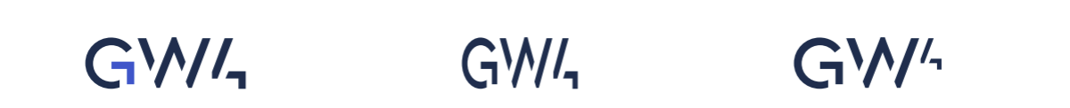


Font

Tenorite is our brand typeface and should be used for all print and digital assets produced.

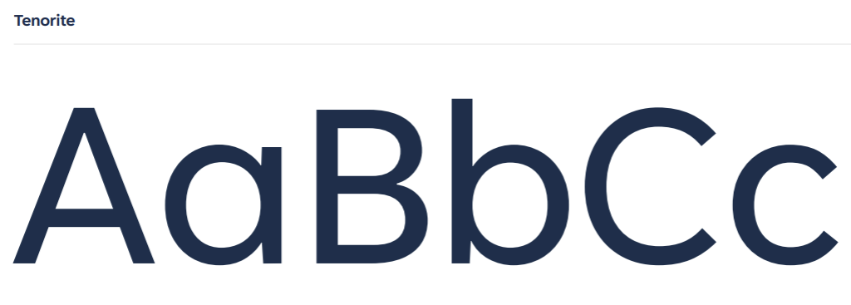

Colour palette
Expertise Navy and Innovation Blue are our two primary colours. These colours should be used across all communications including print and digital applications.
GW4 Primary Navy: Hex code #1a2e4d
GW4 Primary Blue: Hex code #2e58c9
Our secondary palette consists of five supporting colours that can be used in combination with the primary palette. They should not be used solely in combination with each other.

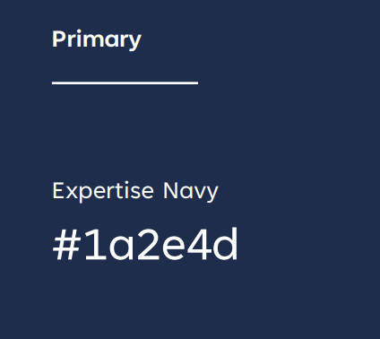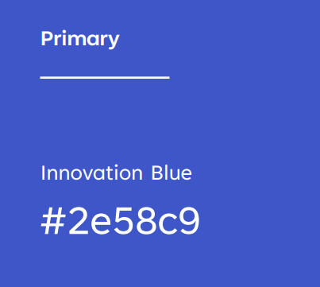

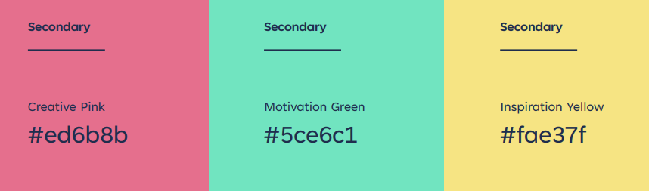
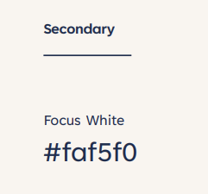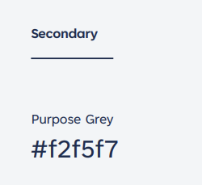

To ensure accessibility for all our audiences, it is crucial when working with type and colour to use combinations that have a strong visual contrast. Please follow the accessible colour combinations in the full GW4 Branding Guidelines, so we can create colour combinations that are accessible to everyone.

Communications support for our research communities
GW4 Communications Channels
The GW4 Alliance promotes its work and programmes and projects through the following channels:
- Website: gw4.ac.uk
- LinkedIn: GW4 LinkedIn
- YouTube: GW4Alliance
We also have accounts on
- X: @GW4Alliance
- BlueSky: @gw4alliance.bsky.social‬‬‬‬‬‬‬‬‬
Research community webpages
GW4 research communities including those from the Generator Fund, Development Award and GW4 Crucible seed fund projects all receive their own webpage on the main GW4 website.
https://gw4.ac.uk/our-communities/
https://gw4.ac.uk/gw4-crucible-seed-projects/
These pages can provide a useful link when promoting your research community to others. Content and information updates provided by the research communities can be added to these pages by the GW4 Building Communities Manager.
If you would like a broader online presence than your GW4 community webpage allows, some communities have chosen to create their own websites. This is entirely optional, and not routinely recommended, but in certain circumstances can be beneficial.
GW4 does not have the capacity to create or support websites, and we would suggest thinking carefully about the maintenance and longevity of the site. Please also consult your institution’s accessibility guidelines to ensure any web content meets Web Content Accessibility Guidelines (WCAG). We recommend contacting your university’s web team for further guidance.
You may also want to think about alternatives such as a LinkedIn page to help promote your research community or project.
Promoting events and activities
If you would like to share frequent iterative information about your project (such as small milestones or project-specific blog posts) a separate blog platform or social media channel like LinkedIn may be a more appropriate way to reach your targeted audience.
If your event is open to colleagues across the GW4 institutions (Bath, Bristol, Cardiff and Exeter) and/or members of the public, GW4 may be able to help promote your event via our networks, institutional channels or LinkedIn. Please tag @GW4Alliance on the relevant LinkedIn post you would like us to reshare to our followers.
Templates and promotional materials

The following items are available as pre-set GW4 branded templates:
- Word document
- PowerPoint presentation slides

Contacts
GW4 Communications: comms@gw4.ac.uk
GW4 Team: https://gw4.ac.uk/meet-the-team/
GW4 Programme Managers:
- Bath GW4-PM@bath.ac.uk
- Bristol GW4-PM@bristol.ac.uk
- Cardiff GW4@cf.ac.uk (also copy in PattenK1@cardiff.ac.uk)
- Exeter GW4-PM@exeter.ac.uk
How are we doing?
We welcome feedback on our communications. If you have any thoughts to share, please do let us know by emailing info@gw4.ac.uk.

